Workflow for bidding a need on twoplugs.com

Requirement:

* remove refund % and refund valid when creating a new need on the website. See 1.png
* remove refund % and refund valid from the New Bid message sent to the owner of the need. See 2.png
* The New Bid message page will now have 3 buttons. See 3.png
* Decline Bid button should work like it currently works for "Deny Bid" button
* Accept button should work like it currently works for "Confirm" button
* Make an offer is the new button. When clicked should open the pop up. See 4.png
* The user should able to enter a new price and a message. Message is optional. See 4.png
* The seller trying to meet the need will receive a new message Title " New Bid Offer" See 5.png
* Same idea here. the seller will have 3 buttons: Decline Bid, Make an Offer, Accept. See 5.png
* If the seller clicks on Make an Offer, then display the pop up in 4.png. and the process repeats
* The owner of the need will also get a "New Bid Offer" message and the same process repeats
* The process stops when seller or owner of the needs pushes "Decline Bid" or "Accept"
* As always make sure when there is a new message "New Bid Offer", ensure all "New Bid" messages about the same transaction are no longer active (i.e hide all the buttons). This is to prevent a user from accepting a "New Bid Offer" and also accepting an older "New Bid"

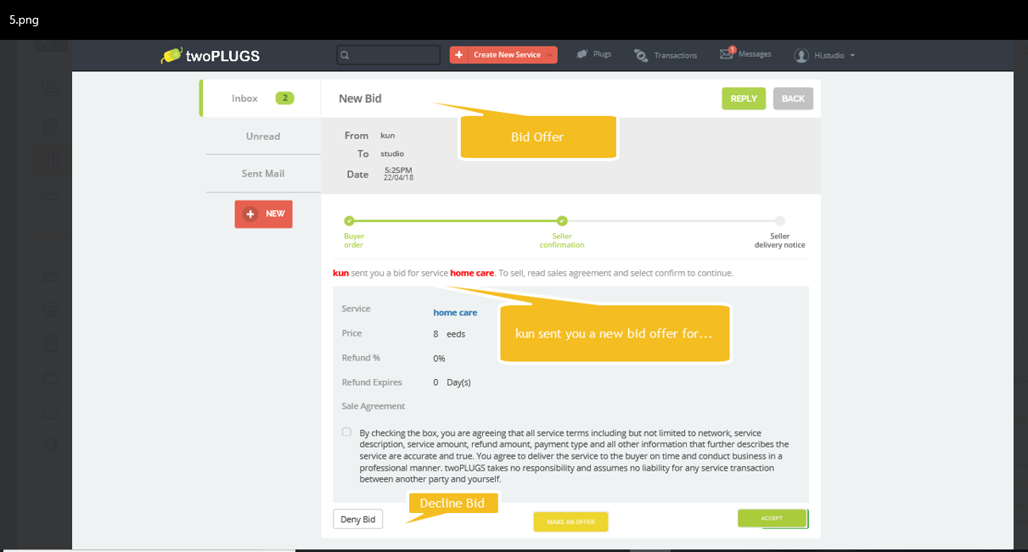

5.png

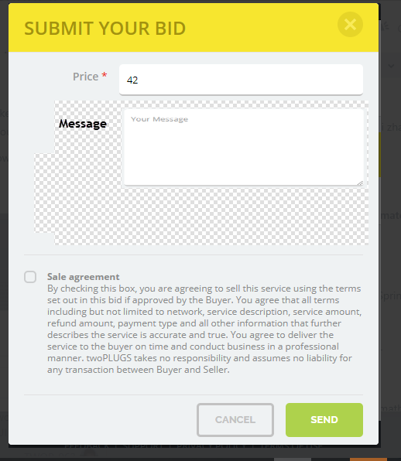

4.png

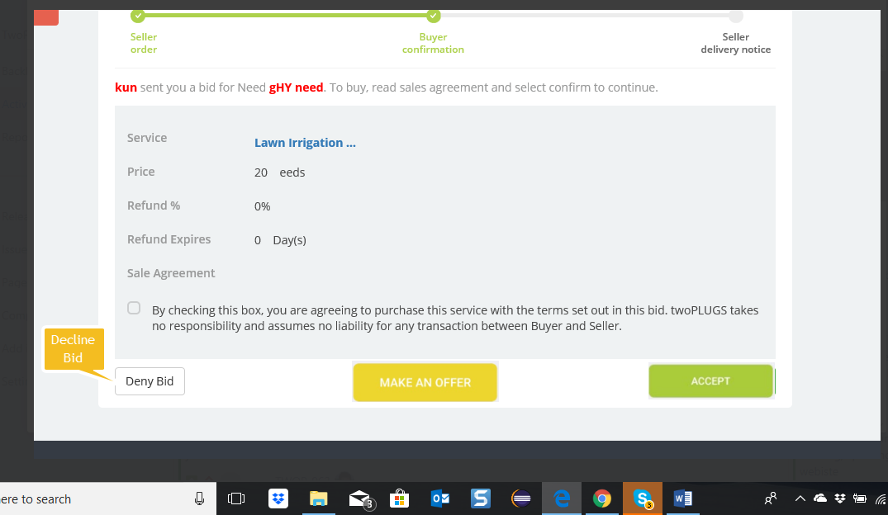

3.png

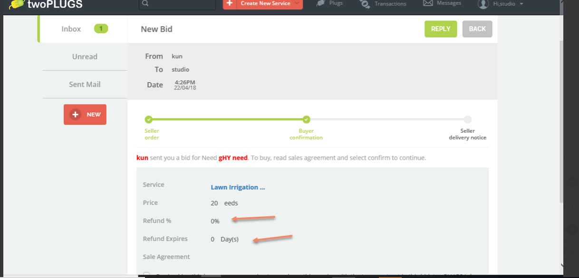

2.png

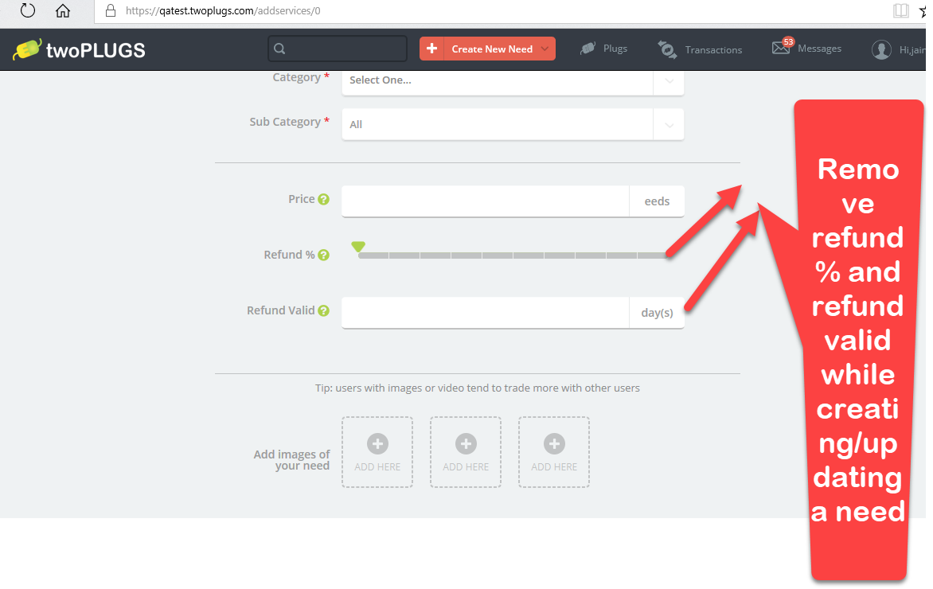1.png